ENPM661 - Spring 2025
Project 03 - Phase 2
Implementation of the A* algorithm on a Differential Drive (non-holonomic) TurtleBot3 robot
Note: This is a group project (max three students*)

Due Date: April 18, 11:59 PM Points/Weightage: 10

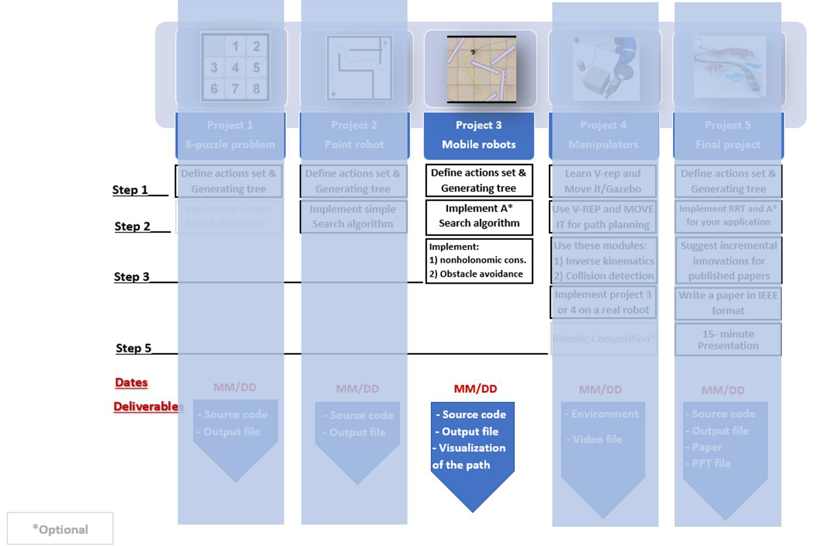

- Navigate a differential drive robot (TurtleBot4) in the given map environment from a given start point to a given goal point.

  - If the start and/or goal nodes are in the obstacle space, the user should be informed by a message, and they should input the nodes again until valid values are entered.

  - The user input start and goal coordinates should be w.r.t. the origin shown in the map.

- Consider differential drive constraints while implementing the A* algorithm, with 8 set of action space.

- Your code must take the following values from the user:

  - Start Point Coordinates (3-element vector): (Xs, Ys, Θs).
    - Θs - The orientation of the Robot at the start point.
  - Goal Point Coordinates (2-element vector): (Xg, Yg)
    - To simplify the path explored, final orientation input is not required.

  - Wheel RPMs (2-element vector) => (RPM1, RPM2)
    - RPM: Revolutions per Minute
    - 2 possible values for the wheel RPMs

  - Clearance (in mm)

- Your code must define the following parameters of the TurtleBot 3 Waffle robot.

- These parameters are NOT user defined but rather are constants which can be defined in your Python code.

  - Robot Wheel Radius (R)
    - From the robot’s datasheet/documentation

  - Robot Radius (r)
    - From the robot’s datasheet/documentation
    - This needs to be added to the clearance value to create the obstacle map.

  - Wheel Distance (L)
    - From the robot's datasheet/documentation

- Let the two RPMs provided by the user be RPM1 and RPM2. Then the action space consisting of 8 possible actions for the A* algorithm is:

1. [0, RPM1]
2. [RPM1, 0]
3. [RPM1, RPM1] 4. [0, RPM2]
5. [RPM2, 0]
- [RPM2, RPM2]
- [RPM1, RPM2]
- [RPM2, RPM1]

where, the 1st element in each vector above corresponds to the Left Wheel’s RPM and the 2nd element in each vector above corresponds to the Right Wheel’s RPM.

Example: actions = [[50,50], [50,0], [0,50], [50,100], [100,50], [100,100], [0,100], [100,0]]

Part 01: 2D Implementation

- For this project you consider the robot as a non-holonomic robot which means the robot cannot move in the y-direction independently.

- You will have to define smooth moves for the robot by providing Left and Right wheel velocities. The time for each move will have to be fixed.

- The equations for a Differential Drive robot are:
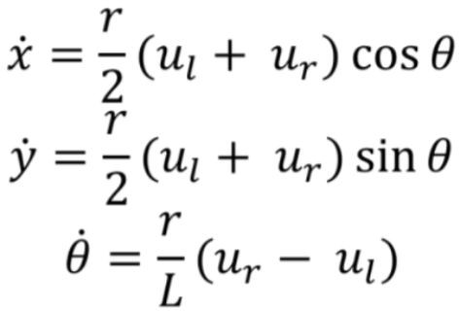
where,
- x_dot and y_dot: Velocities in x and y directions, respectively
- u and u : Left and Right wheel velocities,

From the velocity equations, the distance travelled and angle covered in each time step, dt can be calculated as:
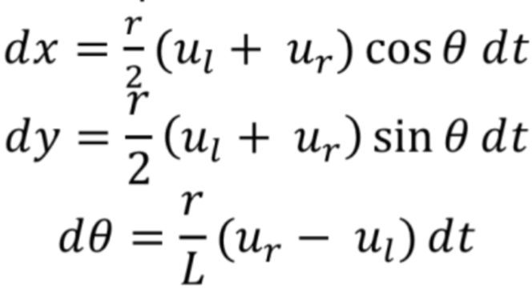

l r

respectively
- r : Wheel radius
- L: Distance between the two wheels
Refer to the given Python file for the equations.

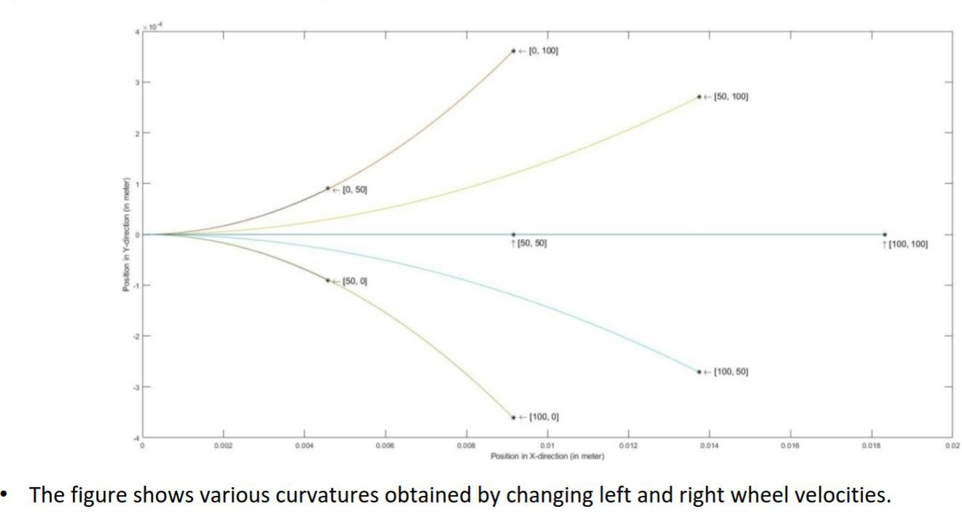

- Write a function that will take 2 arguments (Rotational velocities of the Left wheel and Right wheel) and returns the new coordinate of the robot, i.e. (x, y, theta).

  - where x and y are the translational coordinates of the robot and theta shows the orientation of the robot with respect to the x-axis.

- A sample is provided in the python file. You may choose to modify the function or implement your own.

Rigid Robot

- Dimensions of the robot are available in the Official Documentation which can be used to define the clearance value.

- The map with obstacles can be setup using any inbuilt function of OpenCV/Matplotlib/Pygame. However, it is recommended to use the half-plane equations method.

constraints

- Consider the configuration space as a 3 dimensional space.

- Follow the same step from Project 3- Phase 2 to check for duplicate nodes (consider threshold as per your own need, but make sure the 8-action space is not violated)

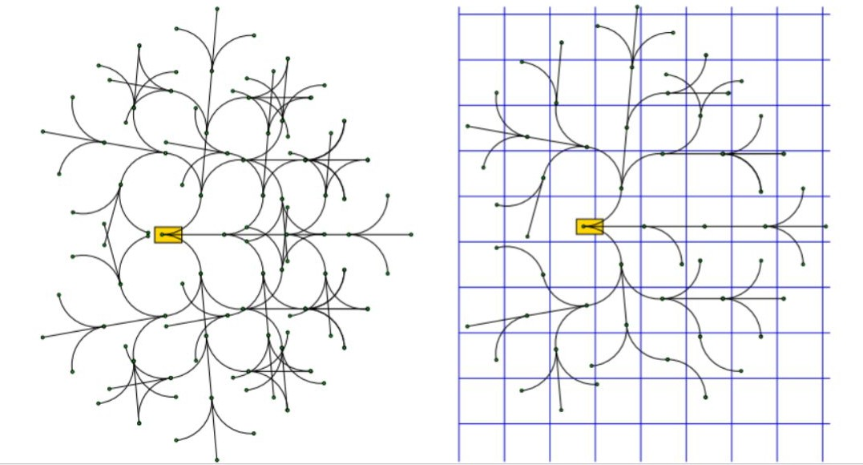

- Use curves that address the non-holonomic constraints to connect the new node to previous nodes and display it on the Map.

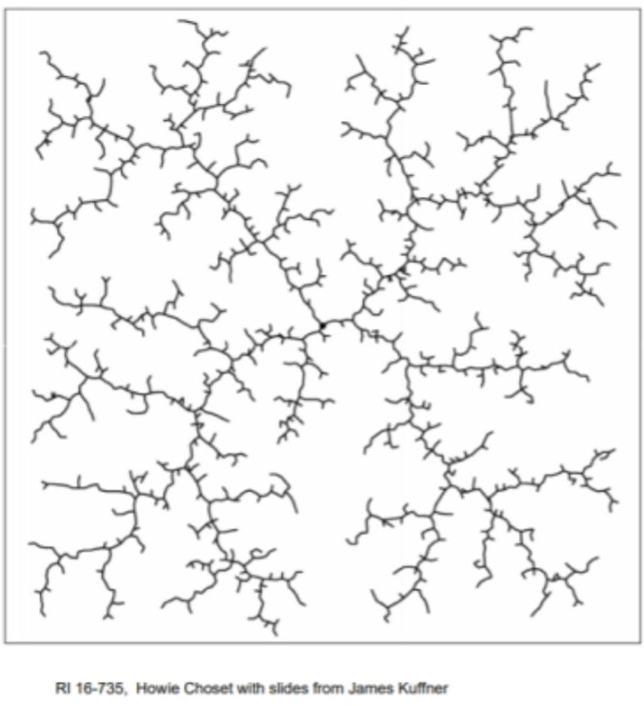

and to find the optimal path

- Consider Euclidean distance as a heuristic function.

- Note:- Define a reasonable threshold value for the distance to the goal point. Do to the limited number of moves the robot cannot reach the exact goal location. So, use a threshold distance to check the goal.
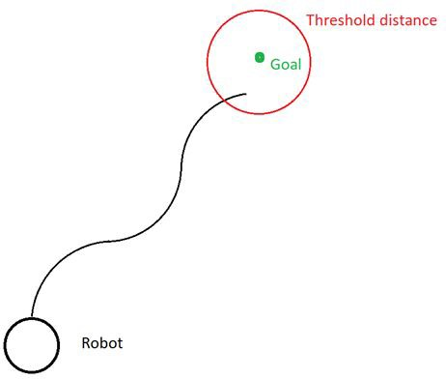

- To plot the final path, you can use the plot_curve function as shown in the given Howplotcurves.py Python file. You may also use other libraries such as quiver to help you plot the path lines of the robot.

- For Part 01 2D Implementation, use the map given in Part 02 in the upcoming slides.
  - You may also choose to use Project 03 Phase 01’s map for Part 01 alone.

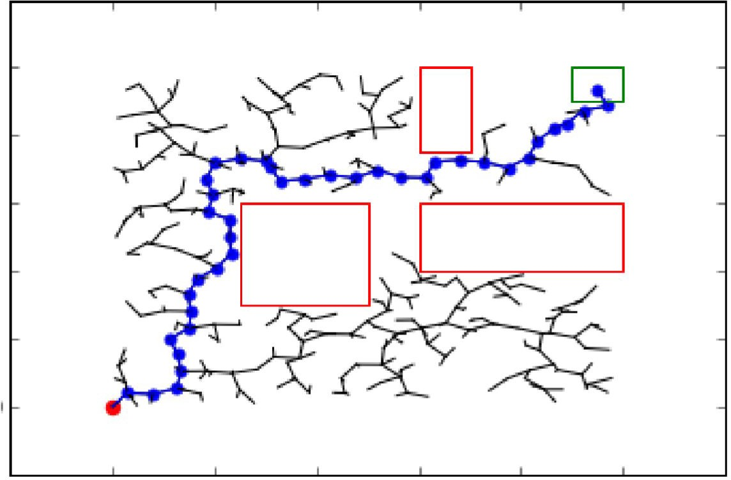

Part 02: Visualization

- Implement Gazebo Visualization

- Simulate the path planning implementation on Gazebo with the TurtleBot 3 Waffle robot.

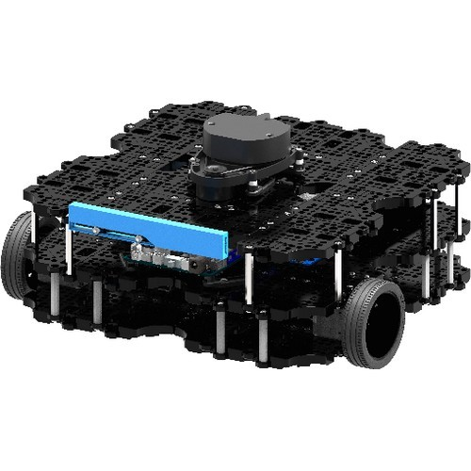
- The Gazebo environment has been provided for the map as a part of a ROS2 package with turtlebot available. Follow the instructions given here to set up your workspace.

- Falcon Visualization (form Duality AI)

- For more information see ppt file

- The approximate start point is shown in red and goal point is shown in green in the Figure below.
  - You are free to choose any start point in the space to the left of the 1st rectangle and the goal point anywhere in the space above/below/to the right of the given goal.

- The video should show the TurtleBot motion in Gazebo environment for these points. The motion of the TurtleBot should be as a result of the solution generated by your A* algorithm and the corresponding velocity commands published to the appropriate ROS topic.

- Choose the start and goal points by your best judgement along with other user inputs, specifically the wheel RPMs and clearance.
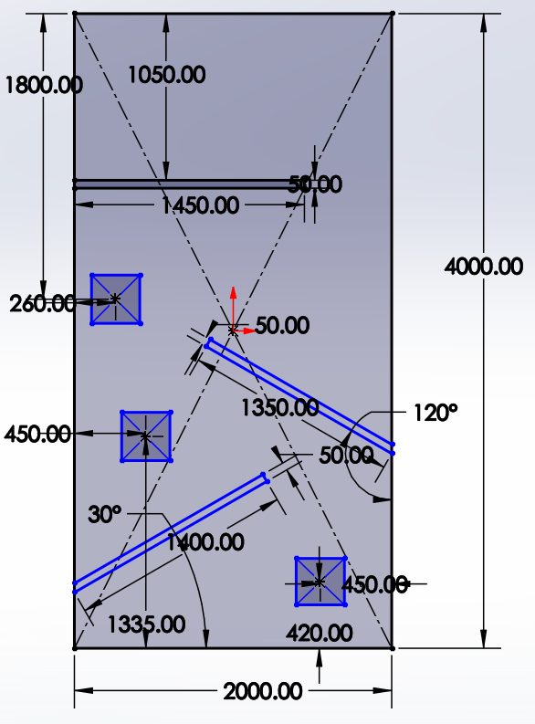
Start point
y
x
End line

The origin shown here is as represented in the Gazebo world.

- To run the simulation in ROS, you should write your script file which will plan and drive the turtlebot to the goal

- You are NOT required to implement a controller to make the TurtleBot accurately follow the trajectory. This will be an open-loop controller and hence, it is okay if the robot does not follow the exact waypoints accurately.

- Make note of the coordinate system in Gazebo, and the position of the origin. Input will be based on the coordinates in Gazebo for Part 02: Gazebo Visualization. Quantities in ROS are reported in meters, radians, meter/sec, and rad/sec.

- User input should be from the Terminal and not hardcoded into the code. Decide the clearance and wheel RPMs on your own.

- Since the map is of size 2000mm x 4000mm, feel free to downsize the corresponding canvas (for example: 600cm x 200cm) for faster exploration. Be careful of these units while publishing the same to ROS topics for Part 02.

- Helpful Links for ROS/TurtleBot3:
  - ROS Tutorials
    - ENPM661 Software Session Tutorial (will be shared)
  - Writing a publisher/subscriber node:
    - docs.ros.org
    - ENPM662 ROS Publisher/Subscriber Software Session
  - TurtleBot3 Installation + Simulation
,
    - Documentation: Simulation

- proj3p2_firstname#1_firstname#2_firstname#3.zip. This zip file should contain the following folders & files in the below tree structure.
  - Part01 folder
    - Source Code (.py)
  - Part02 folder
    - ROS Package
  - README file (.md or .txt)
    - Must properly describe how to run the code (for Part01) and launch the ROS Node (for Part02).
      - Mention all the inputs (give an example set of inputs to run from the terminal)
    - Must mention the libraries/dependencies used (for ex: numpy, matplotlib, etc)
    - Must mention all Team Member names along with their respective directory ID and UID.
    - GitHub Repository Link containing the code(s)
      - Should contain commits (at least 5) with appropriate commit messages, in total, between all members.
      - Initially, set the visibility of the repository to Private and change this to Public after the deadline date.
    - Simulation Video Links
      - 2 Videos [Reference videos can be found in the project folder]
        - For Part 01: Gazebo simulation
        - For Part 02: Falcon simulation

      - Do NOT include the .mp4 files in your ZIP file, upload both videos to Google Drive/YouTube (unlisted, if required) and include the links in the README (ensure proper view access)

- proj3p2_firstname#1_firstname#2_firstname#3.pdf. This file should contain the source code (Both Part01 and Part02) for plagiarism check. This file needs to be submitted ALONG with the ZIP file, and NOT INSIDE the ZIP file.

